For our ongoing clinical trials, we want to recruit on a twitter account that we set up. The URL for this account is (insert). We have already submitted a social media account request for the account, which was approved by the marketing department. Our contact in the marketing department is (insert) . We have been advised regarding the University’s guidelines for having social media accounts and we have worked with Marketing choose appropriate images for the site. Our target audience is going to be (insert) . Additionally, we would like to target support groups for these disorders that would help spread our message.
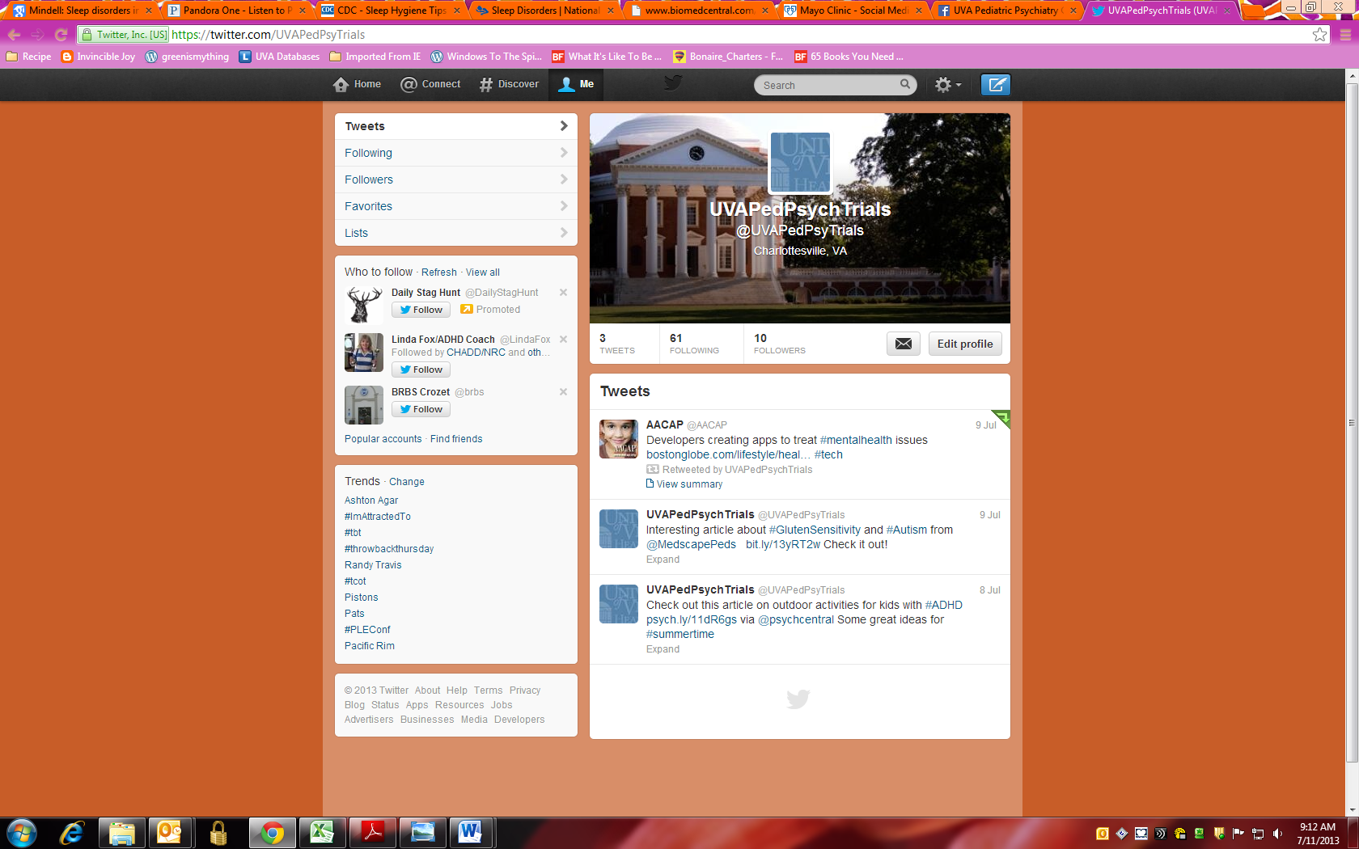
(Insert 2 names)will be in charge of updating and moderating the account. We would aim to have new posts about twice a week. All posts regarding study content will be approved by the IRB-HSR and the sponsor prior to being posted.
Insert Screenshots of the current Twitter page.

In addition you will need to submit a list of possible tweets – see template.

