IRB-HSR Announcements
May 20, 2022

IMPORTANT: Information regarding Critical IV Iodinates Contrast Shortage

https://uvaconnect.com/update-iv-iodinated-contrast-shortage-2/
For protocols that include iodinated contrast studies, be aware that you ARE NOT required to submit a protocol deviation to the IRB-HSR each time that a protocol contrast study is delayed but should instead, keep a deidentified list of the number of subjects affected and include this list with your next continuation protocol status report.
In addition, it is recommended that study teams prospectively communicate this potential delay with research subjects who may be affected.

Submission of Study Documents to IRB HSR via IRB PRO **NEW ROUTE FOR SUBMISSION**

The IRB HSR has created a NEW route for submission of study documents to the IRB via IRB PRO.
https://hrpp.irb.virginia.edu/irbpro/index.cfm

NOTE: This NEW route DOES NOT apply to NEW Expedited or NEW Full Board studies whose applications MUST still be submitted through CRCONNECT.

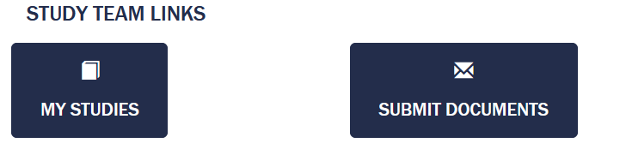

Once logged into IRB PRO, the study team view shows both “My STUDIES” and the
NEW feature “SUBMIT DOCUMENTS”. Click on SUBMIT DOCUMENTS to open the following:

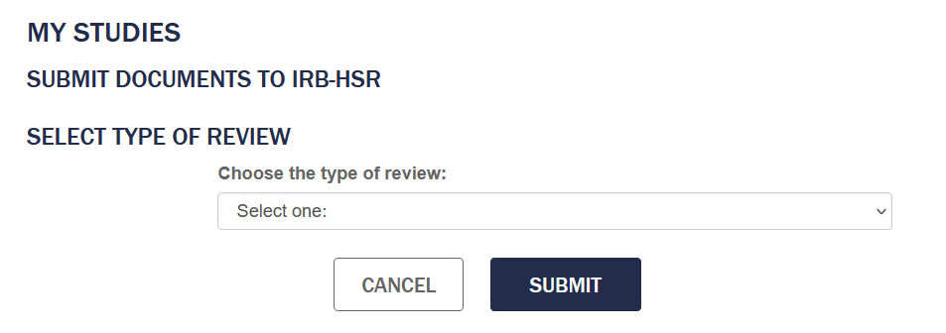
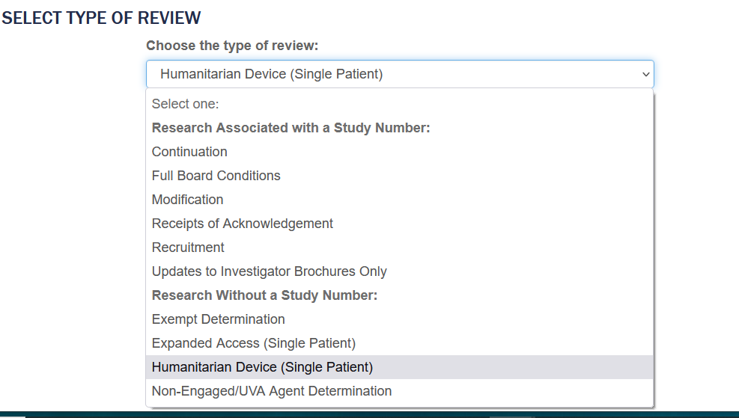

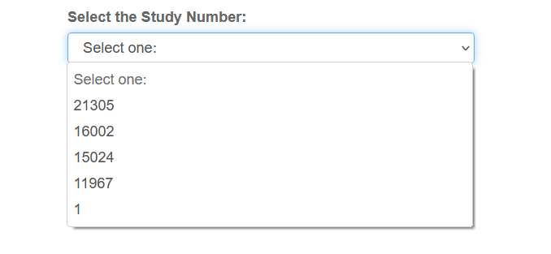

The drop-down menus will provide ALL event options available to submit to the IRB-HSR via IRB PRO along with the study numbers that the sender is listed on.

You will be prompted with the following instructions:

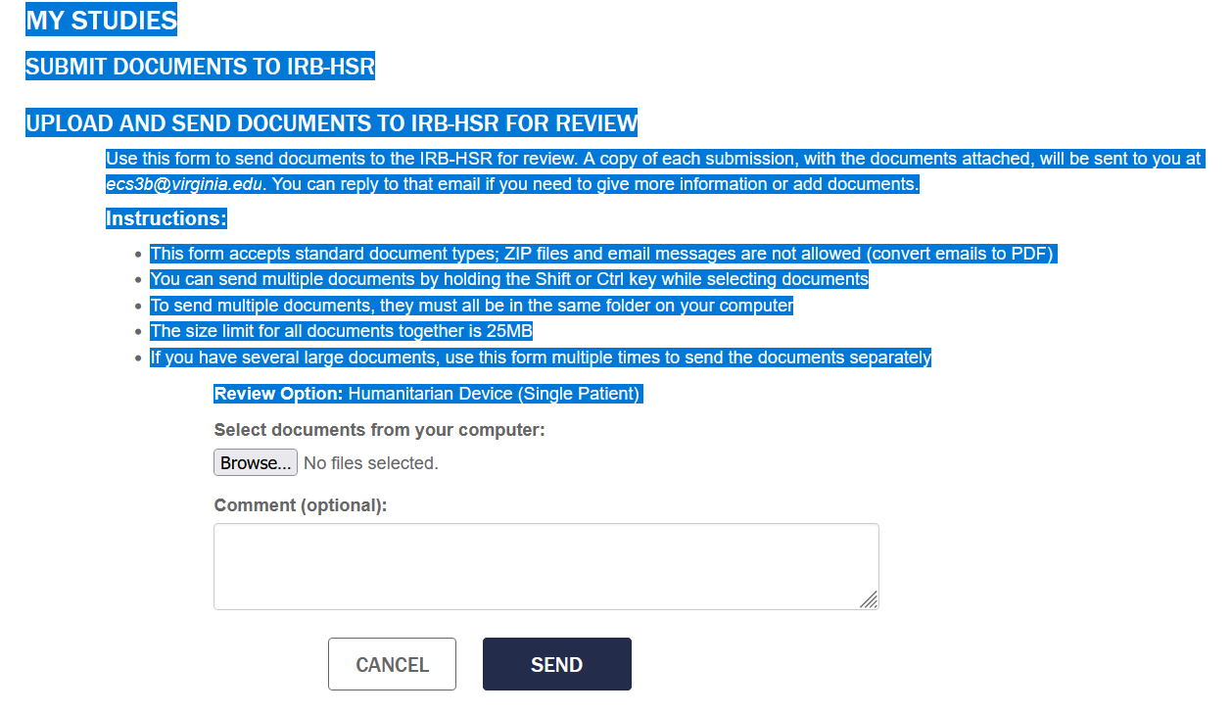

This new feature will also provide an email confirmation to the sender that indicates the study title, PI, type of submission and the list of documents submitted.

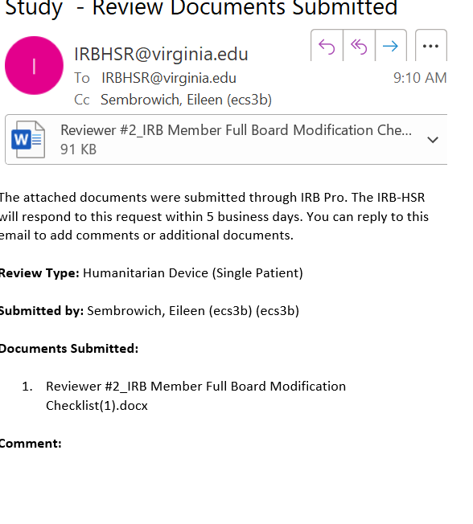
We hope study teams find this NEW feature useful and we welcome any feedback.

